Jeffery Crosby
Sue Briggs
ENGL 2010
T, TH 10:00-11:15
KEYS TO SUCCESS FOR AN AMERICAN PRESIDENT
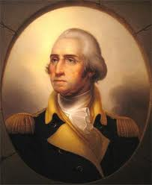
It is a really sunny day and residents in Concord are either in their wooden homes or outside being peaceful citizens. Then a bunch of red coated men show up and start firing off a bunch of gun shots at rebels on a bridge but are forced to retreat. (“Lexington,” par. 5)From this act made by the Red Coats (British), war is officially declared! Only problem is that the British are very strong in numbers, so, the search was on for an individual with the skills to be able to lead an army into battle. Eventually the person is found that would be capable of bringing victory against the British.
The man is very tall with white hair that had fought in the French and Indian War as a lieutenant, colonel, and commander in chief. (“George,” par. 3 & 4)This man’s name is George Washington! As general of the American army, he led countless attacks against the Red Coats with not many victories but kept on coming back and achieved success. This was all due to him never giving up hope, having belief and faith in his men, and the tremendous courage put into fighting against the enemy. Because of these positive qualities George Washington was able to survive and lead his army; one battle after another, that in the end victory was achieved. This though was due to him never losing hope in not just his men, but the rest of those who lived in the thirteen colonies.
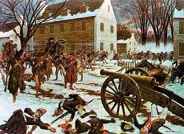
Martin Luther King Jr. once said, “We must accept finite disappointment, but never lose infinite hope.” He’s clearly saying that though not everything people want to happen can but they must always have hope that some of those dreams will become a reality. Hope is a tool that should never be overlooked or underestimated because when it seems that all is lost, situations can suddenly turn for the better. Take the Autobots in Transformers for example who searched many years in space for the AllSpark in high hopes of restoring their planet Cybertron. They were starting to think that their home would be nothing but a wasteland forever but then, hope finally allowed them to find it. The same happened to George Washington. The Revolutionary War consisted of many fights but the problem was that the British army was winning most of those battles and from this the Continental Army suffered. Although, even in the blankest of times, George Washington still had hope that they would eventually achieve a win. After being appointed general of the Continental Army, his first battle took place at Bunker Hill in 1775, where the British unfortunately overran the enemy and won. (Kindig) From there on, the Redcoats (later joined by German soldiers) kept on defeating the U.S. army until finally in December of 1776; George Washington’s hope for a victory came in taking a Hessian base in Trenton. (Kindig) From this successful battle, it goes to show that hope can always come anybody’s way that keeps it within not just themselves but even those around them. General Washington’s hope though was also due to the belief and faith he had for his soldiers.
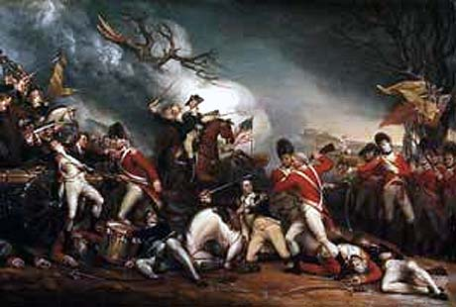
Life is a gamble and in the time a person has in their lifetime, they are faced with hardships. That was exactly how it was for those men who fought for the liberty of the United States. The Revolutionary War was a very hard time for many American soldiers who weren’t sure if the Continental Army would even be able to win the war against the British. But why was this? The answer is that they didn’t believe and have faith in themselves! This though of course changed all due to George Washington showing belief in his men by leading them into battle and then giving them faith to fire their pistols at the enemy. As is said now days, “Have faith and good things will happen.” Also, “Believe in others and they will believe too.” Because General Washington showed belief in his men, they followed him into battle every time (not winning all the time) with faith that they would achieve success. This is like a person trying to go for a high grade point average, which isn’t the easiest thing to accomplish. This though can be achieved if a person has faith in their abilities and believe that they can reach that goal (with support from friends and family), then they will hit the high honor roll. George Washington was able to get another victory after Trenton in the battle of Princeton in 1777. Here the American army outmaneuvered General Cornwallis (British troop) and drove his soldiers towards Brunswick, New Jersey. (“The Battle,” par. 3 & 21) Here was another triumph for Washington and his comrades that his men now were for sure going to win the war against the English forces and be nothing but free and independent. This though of course wouldn’t have become a reality if General Washington didn’t have the courage in order to lead his soldier’s onto the battle field.
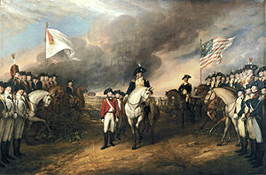
Courage! A very important aspect every last living person on the Earth has within themselves. They just have to be willing to find it inside their hearts and put it to helping out others. Courage has many definitions but it’s when someone puts another person’s welling being before his or her own. George Washington definitely had lots of courage for if he didn’t, then the Revolutionary War would have taken a dive towards the British and probably today America would be under rule of a hierarchy. But all thanks to General Washington for being able to stand his ground and show no fear against those who crossed his path, America is to this day, a land of free willed people. This is just like Harry Potter who was faced with fighting Voldemort and his dark army. All the time Harry always stood his ground against anything that came his way; whether it was Dementors or Death Eaters until it came to where the ‘Boy Who Lived’ and his mortal enemy faced each other for the final time with the courageous boy coming out as the victor. After the battle of Princeton, the Continental Army again weren’t having much luck with defeating the Red Coats except for at Ridgefield, Bennington, and a few other locations. Through all those defeats, George Washington still showed courage to continue facing the enemy, even in the most hard of times until the final battle. In 1781, the American (accompanied by French soldiers) army surrounded the British at Yorktown by land and sea with nonstop fire, forcing General Cornwallis to surrender and bring victory for America! (Kindig) Courage goes a long way but there are more aspects that go into bringing success and by putting them together, anyone can achieve anything and make it become reality.
Success isn’t always easy to accomplish but by showing hope, belief and faith, and courage to make it happen, just like George Washington, then it’ll be achieved. Hope is something that can turn the worst scenarios around for the better and go in the favor of the doubtful so never ever give it up. Belief and faith are one of the same, for if no one believes then they don’t show faith in others and themselves. Courage comes to those who have heart to stand up for others and protect them from harm. General George Washington showed these qualities in his battles against the British and successfully brought victory to America and still to this day, he is a true icon of inspiration. So never forget the man of many virtues who shall always be remembered and honored as a hero for his brave soul!
REFERENCES
- “The Battle of Princeton.” Britishbattles.com. 2010. Web. 29 Jan. 2012
- “The Battle of Lexington and Concord.” Wpi.com. 2 Oct. 2006. Web. 1 Feb. 2012
- Kindig, Thomas. Timeline of the Revolutionary War. Ushistory.org. Independence Hall Association. N.d. Web. 1 Feb. 2012.
- “George Washington.” Sc94.ameslab.gov. Web. 1 Feb. 2012
- “Martin Luther King Jr.” brainyquotes.com. 2001-2012. Web. 1 Feb. 2012

